Design, assembly and distribution of a low cost, automated, open source Bioreactor using a light inducible protein synthesis system for the production of molecular biology reagents required in COVID19 and other viral diseases diagnostics.

Adrian Philip, Alexander Ikolavie, David J. Castillo-Cornejo, Alexander Klenov, Therese Schachner,

Keywords:

Collaborative biotechnology, open electronics, open genes distribution, DIYBiotechnology, Protein engineering, Additive manufacturing, COVI19 testing, citizen science, technology democratization, optogenetics, Makers, Biohacking, portable devices. viral load. fluorescent proteins.

Authors affiliations and institutions:

Ottawa Bioscience, Ontario Canada,
Glyxon Biolabs, Mexico City, Mexico

Abstract

The objective of the present work was to develop a low cost, portable, modular, easy distribution, and minimal maintenance automated bioreactor, accompanied with a comprehensive protein biosynthesis system that relies on an optogenetic induction switch. This open source, modular, reusable wave bioreactor with a controllable environment allows for the production of reagents, including those required for the COVID-19 test to detect the coronavirus. Since this bioreactor costs less than $300, it provides an affordable solution to the issue of reagents that are often expensive or difficult to obtain, resulting in the increased accessibility of bioreactors and reagents for research and production purposes. Within this bioreactor, variables such as temperature, optical density, pH, and dissolved oxygen can be controlled in order to create the environments necessary to produce cells like bacteria, yeast, insect or mammalian cells suitable for production of reagent proteins, antibodies, viral vectors, etc. A team of members from various geographic regions collaborated remotely to design the bioreactor through online communication channels, as well as implement and test the bioreactor in the labs to which team members had access. We are sharing the open source documentation and a production organism kit with the materials to build the bioreactor so that it can be built at an affordable cost.

Introduction

During the winter of 2019, a novel zoonotic coronavirus strain SARS-Cov2 was identified in patients with a rare and devastating Severe Acute Respiratory Syndrome or COVID19. Since the onset of the pandemic outbreak SARS-Cov2 virus has propagated rapidly across borders, jeopardizing the sanitary response of even the most advanced governments and economic blocks of the world to contain and fight the emergent disease. One of the most important challenges is the brevity and availability of the biological reagents required to test the presence of SARS-Cov2 for an expeditious and accurate diagnosis in equally clinically symptomatic and asymptomatic individuals. The current gold standard for the identification of SARS-Cov-2 is the RT-PCR reaction.

Tests provide crucial information for the identification, isolation and control of infected individuals, they offer invaluable information that helps to reduce the impact of the size of the outbreak and selectively limit the mobility of positively identified carriers, in order to minimize the contagion and reduce the workload of the healthcare personal, these measurements facilitate decisions takers estimate the initiation of early treatments that could lead to a satisfactory patient recovery. However, the cost of the enzymes and reagents represent a prohibitive expenditure for many hospitals and governments in developing nations or pose serious distribution obstacles for remote and inaccessible areas.

Materials and Method

Production Vector Construction
The plasmids contained pDawn, which was cloned when exposure to blue light activated the promoter inducing protein transcription and translation, and removal of the blue light halted the protein production, resulting in gene repression. Blue light was selected as the light source due to blue wavelengths’ narrow intensity peak that allowed for fine control of promoter activation. To facilitate column attachment and downstream processing, additions such as His tags were made to the plasmids. RFP served as the reporter for gene expression.

The plasmids were pDawn-Taq, pDawn-pfu-sso7d and pDawn-Mashup-RT. To clone these plasmids, the pDawn backbone was first linearized by PCR to generate overhangs necessary for TEDA assembly. The PCR reaction contained 1X Q5 Reaction Buffer, 1X GC Enhancer Buffer, 200 μM dNTPs, 0.5 μM pDawn-TEV-Vec-For primer, 0.5 μM pDawn-TEV-Vec-Rev primer, 0.5 ng pDawn-RFP plasmid, 1U Q5 DNA polymerase in a total volume of 25 μL. The PCR cycling conditions were as follows: initial denaturation at 95° C for 90s, 35 cycles of 95° C for 30s, 60° C for 30s, 72° C for 240s with a final extension of 72° C for 480s. Six reactions were pooled and treated with 20U of DpnI at 37° C for 2 hours. The PCR product was purified with a Biobasic PCR Purification kit and concentrated by vacuum centrifugation. Concentrated product was separated on a low-melt agarose gel and the 7.2 kb fragment was excised, purified with the Biobasic Gel Extraction kit and quantified by spectrophotometry. The Taq, pfu-sso7d and Mashup-RT inserts were purified as described above except that pAK-Taq, pET-28b-pfu-sso7d and pML-MashupRT plasmids were used as template with their respective primers. The assembly reaction contained 1X TEDA mix, 50 fmol of pDawn vector backbone and 150 fmol of insert in a total volume of 10 μL. The reaction was incubated at 30° C for 1 hour, and 1 μL was transformed into 100 μL DH5α competent cells. Colonies were screened for the correct insert by colony PCR with the same primers used to generate the inserts. The insert sequence was verified by plasmid isolation and Sanger sequencing.

The Gibson assembly procedure was used for vector construction from DNA fragments. The vector construction included maltose binding protein (MBP), TEV. proteinase and light inducible plasmids pDawn (ref). With pDawn, exposure to blue light activated the promoter inducing protein transcription and translation, and removal of the blue light halted the protein production, resulting in gene repression. Blue light was selected as the light source due to blue wavelengths’ narrow intensity peak that allowed for fine control of promoter activation. To facilitate column attachment and downstream processing, additions such as His tags were made to the plasmids. RFP served as the reporter for gene expression.

The DNA fragments were generated via PCR. Agarose gel was used to determine yield and purify the fragments. The fragments were then merged using T5 exonuclease to split the DNA ends to allow for the annealing of complementary fragments. Phusion DNA polymerase added the remaining base pairs, and Taq DNA ligase was inserted to unify the fragments into DNA molecules (4). The plasmids were then used for bacterial transformation.

Growth Conditions
The bioreactor vessels are reusable silicone bags which, compared to glass containers, are less expensive since they do not require 3D printing of PP toxic filaments, are less fragile and are less bulky alternatives to glass jars.
A pump injects oxygen into the culture, which is approximately ⅓ the size of the bag. External agitation as a means of oxygen exposure, eliminates the need for shafts and propellers in the media and makes possible the growth of mammalian cells as shearing forces are less damaging. External agitation also enhances modularity, decreases the risk of leaks and simplifies the device layout and the autoclaving process. ___ was the sensor detecting oxygen transference rate (OTR), which served as a metabolic indicator of the rate at which the cells were absorbing oxygen.

The two environments used were 37°C at an optical density of 0.6, which requires a longer wait time than the other condition of room temperature and an optical density of 0.8 to 0.9.

An built in induction control system allows for production of several difficult enzyme classes like enzymes toxic to the host organism. Proteins from open sources or proteins that have an expired patent and other Open sources are cloned in the induction system.

Hardware Design
Motherboard
The sensor actuator system consists of an ESP 32 controller which operates a NEMA 17 stepper motor, and four peristaltic pumps. Advantages of the ESP 32 include Bluetooth and WiFi connectivity, a fast processor, and a large memory space.

An optional OLED display shows key parameters, including pH and temperature, and their values. A WiFi controller is used for communication between the display and the software.

Rocker
The rocker contains a lengthwise vertical beam supporting a baseplate and ball bearings mounted with laser-cut plates. The display rests on a moving component that slides out to a maximum of 10cm.

Motors control pH and pump air. Two heating pads control temperature. Sensors monitor cell media, temperature, pH, optical density. A set of 560-580 nm LEDs is used for protein induction detection.

Open Source Software
An Open Source JS library project is used for visualization of the data in real time. This allows for monitoring of the conditions inside the bioreactor in real time, either locally or remotely since the data from the run is transmitted over WiFi. The user can select which parameters to add to the line graph (shown on the left hand side of the screen), which displays how they change over time and how they compare to their target values. On the right hand side is a chart showing the real-time numerical values for each parameter, the parameter target values, and the current states of pumps and other devices controlling bioreactor conditions. The user also has the option to reset any of the controlled parameters to their default states.
The software also allows the user to compare multiple programs, each corresponding to a separate experiment, for the purpose of recording and analyzing past data. AI algorithms, trained on past data, determine how to optimize future experiments.
The software was developed in Eclipse.
Pre-existing software is used for temperature and OD600 determination.

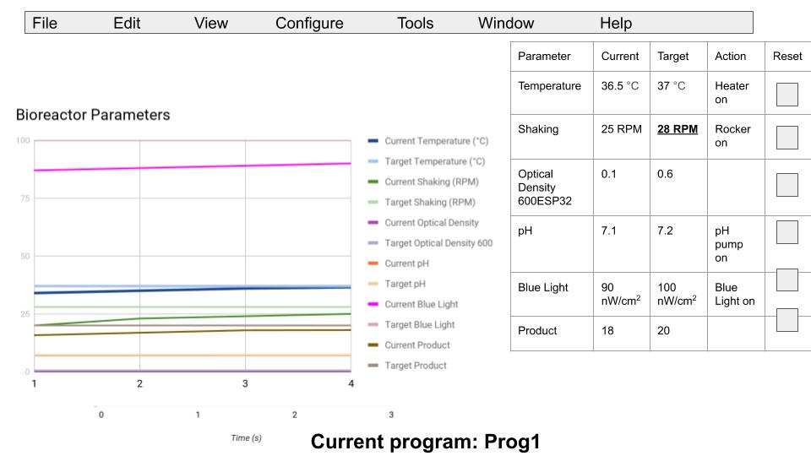

Method Validation

Results
- Efficiency in producing protein
- Silicon bag produced __ quantity of bacteria
- Software: you can watch from 3 screens
- Cost reductions: references #4, #51, #52
  - ~10x cheaper than average (see BOM)
  - Less than $200. Software used to keep cost down

Discussion
Design Implications
Implications of this bioreactor include the accessibility to a bioreactor that is extremely affordable compared to commercial ones. Anyone is free to follow the open source documentation and assemble the modular components into this bioreactor and use it to generate reagents. The access to a cheaply produced bioreactor enables the production of low-cost reagents, since making them is considerably less expensive than purchasing them. As a result, both the bioreactor and the reagents have a substantial return on investment. By reducing duces the impact of cost as an exclusionary factor to reagent production, our bioreactor contributes to the democratization of biotechnology, which is characterized by the increased popularity of do-it-yourself (DIY) designs that allow for the building of biotechnologies with affordable and readily available materials, which empowers many more people to experiment with (6 -- page 125, 127, 128). The presence of open source, low cost hardware and scientific equipment also has the effect of decreasing costs of commercial versions due to competition (1). With this bioreactor, researchers can create new tests or vaccines that can be used to detect or treat COVID-19, as well as other diseases. Since our design allows for the increased use of bioreactors, it also enables increased production of these tests, as well as cells, proteins, etc. with medical and research applications, that can then benefit a greater percentage of the general public.

Future Developments

Future iterations of this bioreactor could include further enhancements. Since the bioreactor is reusable, researchers can experiment with different variables in the controlled environments to discover how to optimize these reactions and create more effective reagents. The ESP 32 controller could be replaced with a larger processor to allow for more memory storage. Additional settings could be added to allow for the production of new types of reagents.

Since this bioreactor, as well as other open source designs, is publicly available on the Internet, there is an opportunity for collaboration among research groups. Researchers have the opportunity to offer feedback on and further expand upon these existing designs by incorporating their own ideas in order to further improve these devices (5). Since a remote team built this device, there is potential for future teams to assemble, regardless of location, to build upon the existing design.

Biorefinery and the future of Bioeconomy

Successful sustainable economies would likely depend on the migration from non-renewable fossil fuels into a rational use and production of renewable sources fuels and materials. In recent years the access to efficient, bioreactors are prohibitively expensive even for the
most technologically advanced economies. Nevertheless the opportunity to incorporate smaller, horizontal, low cost modular sources of biomolecules synthesis could facilitate the technological transference into diverse scales and levels of supply chains, representing an enormous cost reduction and overcoming distribution limitations. The advancement of open biorefinery production could be equiparable to additive manufacturing technologies (3D printing, laser cutting, material extrusion etc), where tools and machineries are designed in situ and on demand having a positive impact on the environmental footprint by the avoidance of cumulative, massively produced inventories.

References
- https://www.ncbi.nlm.nih.gov/pubmed/22984059
- https://github.com/
- https://www.thingiverse.com
- https://www.addgene.org/protocols/gibson-assembly/
- https://journals.plos.org/plosone/article/file?type=printable&id=10.1371/journal.pone.0059840
- https://app.slack.com/client/T010L5L681L/C010HURSND6/files/F0130LP3MBK

